



Business Requirement Document
Supply Chain Management
NWS Supplier Registration Fee
DOCUMENT FOR

Table of Contents:
Table of Contents: 1
1. Introduction 3
1.1 Business Need 3
1.2 Expected Business Outcomes 3
1.3 Project Scope Summary 3
2. Business Requirement Details 4
2.1 Requirement Description 4
2.2 Functional Requirements 4
2.3 Non-Functional Requirements 5
3. System Integration 6
4. Business Classification Fields 6
5. Payment Details 7
6. Process Flow 8
6.1 Supplier Registration and Payment Flow 8
6.2 Post-Approval Integration Flow 8
6.3 Process Flow: 9
7. Assumptions & Constraints 10
8. Risks & Mitigation 10
9. Application Prototype 11
10. Open and Close Issues 12
10.1 Open Issues 12
10.2 Closed Issues 12

Introduction

1.1 Business Need
The current supplier registration process at Nama Water Services is limited to the standard Oracle registration page, which does not facilitate pre-registration activities such as classification validation or payment collection. To ensure that suppliers meet business classification standards and registration fees are collected in a controlled manner, a custom registration landing page will be developed.
This page will act as a pre-screening and payment collection gateway before the supplier is onboarded into the Oracle Fusion system.

1.2 Expected Business Outcomes
- Streamlined registration process with reduced manual intervention.
- Improved accuracy and governance in collecting business classification details.
- Elimination of manual payment tracking through automated AR receipt creation.
- Enhanced supplier experience by integrating fee payment, registration, and classification in a single flow.
- Automated integration ensures that once approved, supplier details are correctly reflected in Oracle Fusion Supplier Master.
- For suppliers rejected during registration, the system supports re-registration without requiring a new payment, ensuring transparency and efficiency.

1.3 Project Scope Summary
The scope of this requirement includes:
- Development of a **custom web-based registration page** to collect supplier classification and initiate payment.
- Integration with **Bank Muscat Payment Gateway** for fee collection and real-time confirmation.
- Conditional **fee exemption logic for Riyada suppliers** based on supplier type.
- Automatic **AR Receipt creation** in Oracle Fusion upon successful payment.
- Seamless **redirection to the standard Oracle Supplier Registration page**.
- **Integration layer** to transfer classification data and attachments to Oracle Supplier Master post approval.
- Re-registration logic allowing rejected suppliers to resume the process without additional payment.

Business Requirement Details

2.1 Requirement Description
The new supplier registration process will begin at the custom registration landing page rather than the Oracle default registration screen. Suppliers will be required to select their supplier type, input business classification information, upload supporting documents, and make the registration fee payment (if applicable). Also CR field should restrict the supplier has already done the payment or already available in the Supplier master
For Riyada suppliers, the system will automatically recognize the exemption criteria and skip the payment collection. Once payment is completed or exempted, suppliers will click the **"Proceed for Supplier Registration"** button, which will redirect them to the Oracle registration page to complete the formal registration process.
Upon successful payment, an **AR Receipt will be created in Oracle Fusion** to ensure the payment is recorded against the correct revenue account. After supplier registration approval, the classification details captured on the custom page will be pushed to the Supplier Master, ensuring data accuracy and eliminating duplicate data entry.
In the event of a rejection during the approval workflow, suppliers will be able to return to the custom page and reinitiate registration without paying the fee again.

2.2 Functional Requirements

Sr. No. | Functional Requirement | Detailed Description
1 | Custom Registration Page | A responsive web page to collect Supplier CR Number, Supplier Type, Business classifications based on supplier type with attachments, and payment. Supports validations.
2 | Riyada Fee Exemption | For suppliers identified as Riyada, system bypasses payment step automatically.
3 | Payment Gateway Integration | Integration with Bank Muscat gateway with synchronous callback to confirm payment. Secure tokenization and logging to be implemented.
4 | Acknowledgement Notification | System should send a mail notification after payment completion
4 | Redirection to Oracle Page | After payment or exemption, redirect supplier to Oracle Supplier Registration URL with secure token.
5 | AR Receipt Generation | On payment confirmation, AR receipt will be automatically created with correct accounting.
6 | Integration to Supplier Master | Upon supplier approval, classification fields are synced into Oracle Fusion Supplier Master using REST/SOAP API.
7 | Re-registration Support | Rejected suppliers can re-register using their earlier payment without paying again.

2.3 Non-Functional Requirements

- **Security**: All data transmitted must use HTTPS with encryption; no payment information should be stored locally.
- **Performance**: Page response time must be < 3 seconds under average load.
- **Availability**: System should be available 99.5% of the time during business hours.
- **Scalability**: Should support multiple concurrent supplier registrations without performance degradation.
- **Audit**: All key events (payment, redirection, submission, rejection) must be logged with timestamps.

System Integration
System | Module | Integration Point
Custom Registration Page | Supplier Portal | Business Classification Entry, Payment Initiation
Bank Muscat Gateway | Payment | Real-time payment processing and confirmation callback
Oracle Fusion | AR | AR Receipt Creation and payment accounting
Oracle Fusion | Supplier Master | Integration of classification details post approval

Business Classification Fields
Field Name | Description | Mandatory
Certificate Number | Business Classification Certificate Number provided by the supplier | Yes
Business Classification Type | Classification Type (e.g., Riyada, SME, etc.) | Yes
Start Date | Date when the classification certificate became effective | Yes
Expiry Date | Date when the classification certificate expires | Yes
Attachments | Supporting Documents such as scanned certificate copies | Yes

Payment Details
Parameter | Description
Payment Gateway | Bank Muscat
Registration Fee | 100 OMR for Non-Riyada Suppliers
Fee Exemption | Riyada Supplier Type
AR Receipt | Auto-created upon successful payment with mapping to GL revenue account
Payment Mode | Online payment using Credit/Debit Cards and Bank Transfers

Process Flow

6.1 Supplier Registration and Payment Flow
1. Supplier navigates to the custom registration landing page.
2. Supplier Enters the CR Number, Supplier selects supplier type (Riyada / Non-Riyada) and enters business classification details.
3. System validates the input and determines the fee applicability.
4. If Non-Riyada, supplier is redirected to Bank Muscat gateway to complete payment.
5. On successful payment, system triggers AR receipt creation in Oracle Fusion.
6. Supplier clicks the 'Proceed for Supplier Registration' button and is redirected to Oracle standard page.
7. Supplier completes the standard Oracle registration form.

6.2 Post-Approval Integration Flow
1. Oracle Supplier Registration workflow completes and goes for internal approval.
2. Upon final approval, a background integration process triggers.
3. Business classification details collected earlier are transmitted to Oracle Supplier Master via API.
4. If registration is rejected, the supplier is allowed to return to the custom page and re-register without repaying.

6.3 Process Flow:
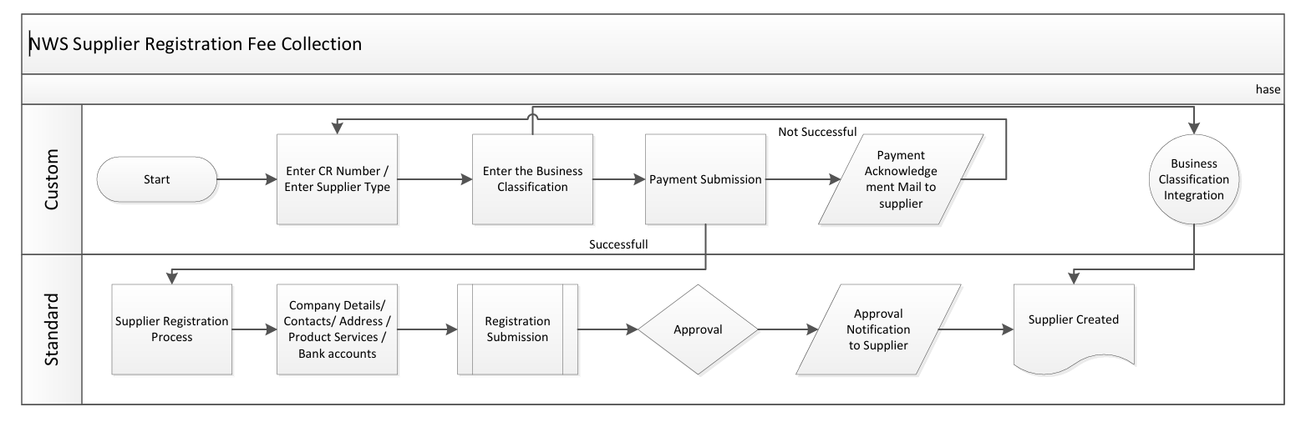
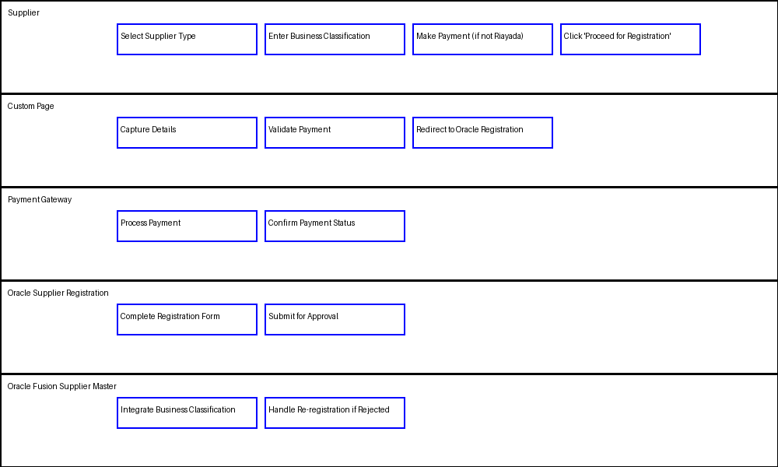

Assumptions & Constraints
- All payment transactions are handled securely through the bank’s gateway and No refund of supplier registration fee.
- Riyada classification determination is based on supplier input but can be enhanced with future validation services.
- Integration services between custom page and Oracle Fusion are active and monitored.
- Supplier attachments comply with allowed formats and file size restrictions.

Risks & Mitigation
Risk | Impact | Mitigation
Payment failure | Supplier registration may be delayed or blocked | Implement robust error handling, retries, and user notifications.
Integration delay | Business classification data may not appear in Oracle immediately | Implement scheduled jobs, retry mechanisms, and alerts.
Misclassification of supplier type | Incorrect fee exemption and loss of revenue | Implement validation controls and audit logs.
API downtime | Integration failure | Enable queuing and retry logic with monitoring.

Application Prototype
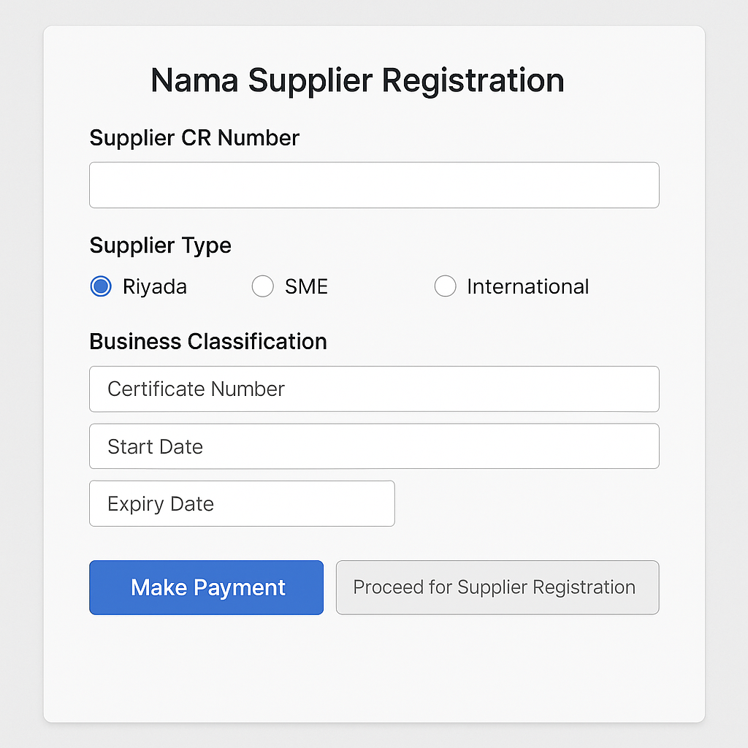

Open and Close Issues

10.1 Open Issues
S. No | Issue | Resolution | Responsibility | Target Date | Impact Date
1
2

10.2 Closed Issues
S. No | Issue | Resolution | Responsibility | Target Date | Impact Date
1
2

